**Chapter 3: Describing Syntax and Semantics**

**1. What is the difference between a sentence and a sentential form?**

**Ans:**

* A sentence is a sentential form that has only terminal symbols. On the other hand, every string of symbols in a derivation is a sentential form.
* Every sentence is a sentential form but every sentential form is not a sentence.

**2. Describe the basic concept of operational Semantics.**

**Ans:**

* Operational Semantics describe the meaning of a program by executing its statements on a machine, either simulated or actual.
* The change in the state of the machine (memory, registers, etc.) defines the meaning of the statement.
* To use operational semantics for a high-level language, a virtual machine is needed.
* Uses: (i) Language manuals and textbooks (ii) Teaching programming languages.

**3. Define syntax and semantics.**

**Ans:**

**Syntax**: Syntax is the form or structure of the expressions, statements, and program units.

**Semantics**: Semantics is the meaning of the expressions, statements, and program units.

Syntax and semantics provide a language’s definition

**4. What is the difference between a synthesized and an inherited attribute?**

**Ans:**

|  |  |
| --- | --- |
| **Synthesized Attribute** | **Inherited Attribute** |
| An attribute is said to be Synthesized attribute if its parse tree node value is determined by the attribute value at child nodes. | An attribute is said to be Inherited attribute if its parse tree node value is determined by the attribute value at parent and/or siblings’ node. |
| If all attributes are synthesized, the tree can be decorated in bottom-up order. | If all attributes are inherited, the tree can be decorated in top-down order. |
| The production must have non-terminal as its head. | The production must have non-terminal as a symbol in its body. |

**5. Is aabcdccc in the language generated by the following grammar? If so, draw the parse tree. If not, show why.**

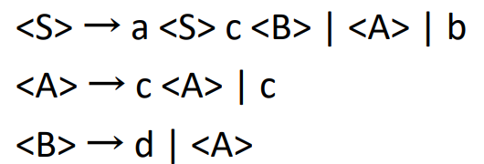

**Ans:** Yes, aabcdccc in the language is generated by the following grammar.

**Parse tree:**

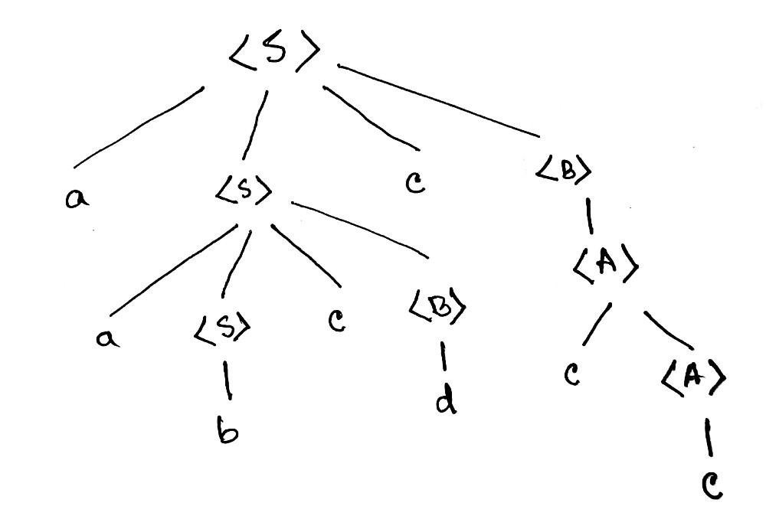

**6. Is aacccdcc in the language generated by the following grammar? If so, draw the parse tree. If not, show why.**



**Ans:** Yes, aacccdcc in the language is generated by the following grammar.

**Parse tree:**

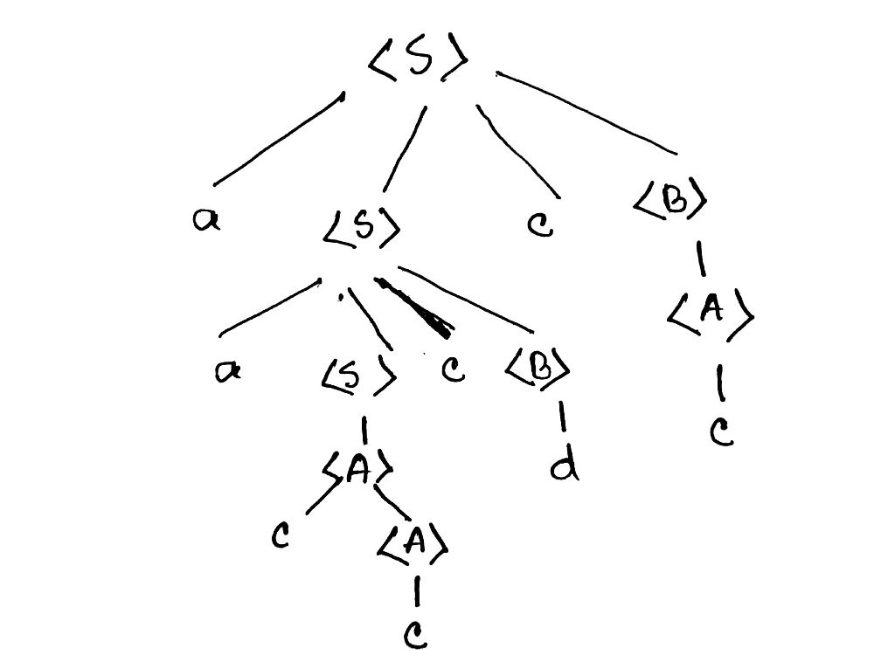

**7. Derive the string ‘acabcdcd’ using the following grammar (make leftmost derivation):**

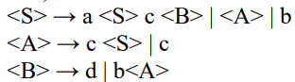

**Ans:** Derivation of the string ‘acabcdcd’:

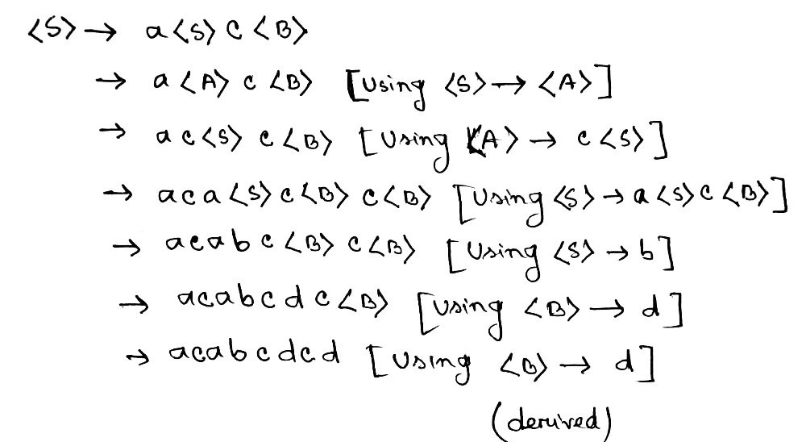

using the Parse tree:

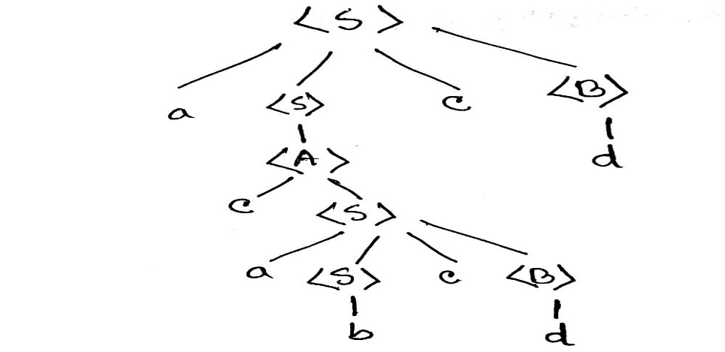

|  |  |
| --- | --- |
| **8.** |  |

**Ans:** If a grammar generates different parse tree, then we can say that, the grammar is ambiguous means it is not a good grammar. The given grammar generates two different parse trees. The parse trees are shown below.

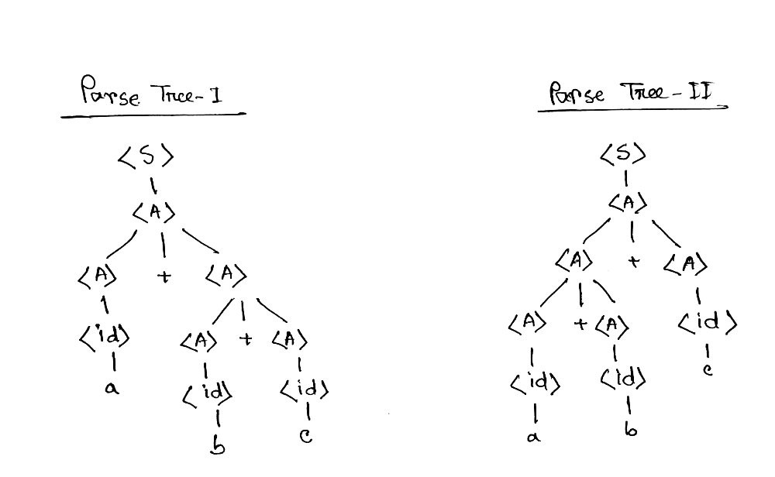

**So, the given grammar is ambiguous.**

|  |  |
| --- | --- |
| **9.** |  |

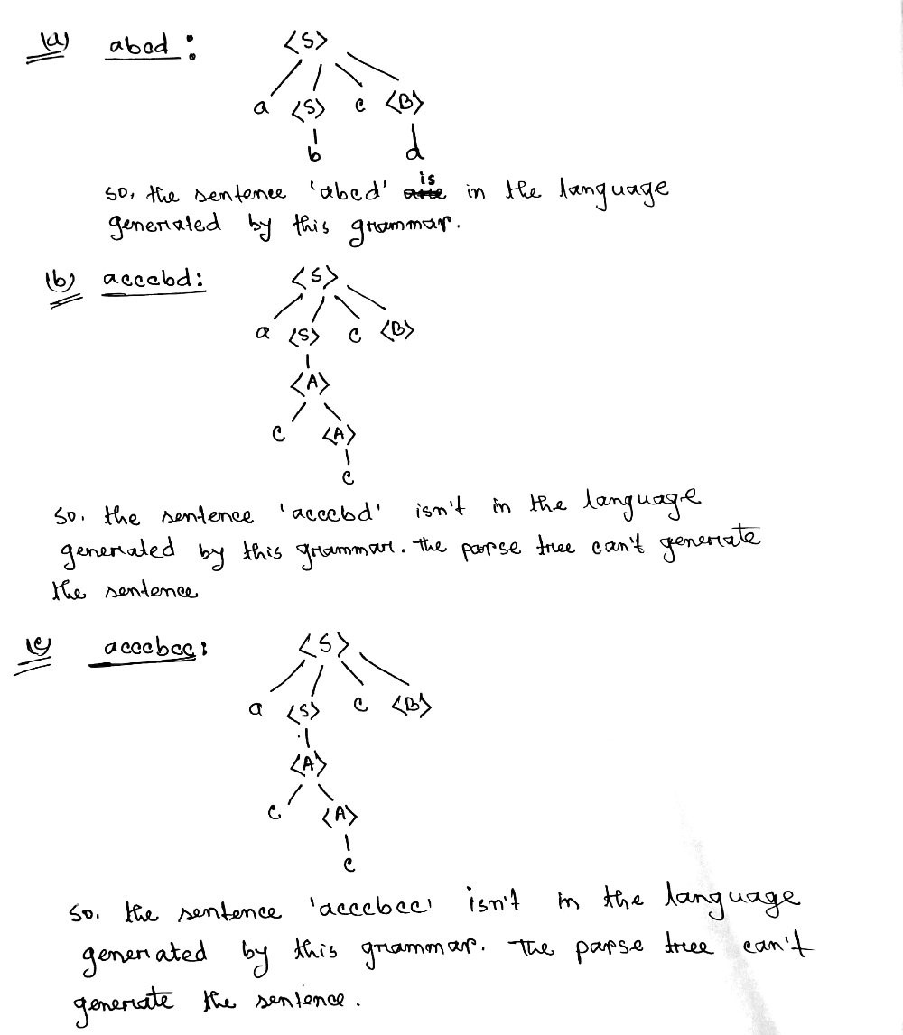

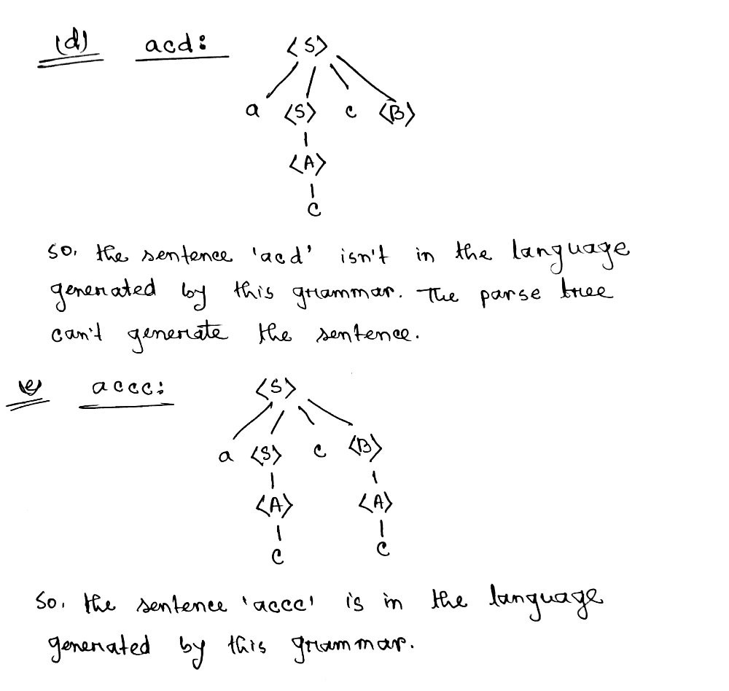

**10. Convert BNF to EBNF**

